Are U.S. exports being unfairly taxed abroad? This report dives into U.S.–Mexico trade data to explore whether the U.S. faces higher tariffs compared to what it imposes on others. Using real 2022 data from WITS, I analyze tariff revenue, product-level trade patterns, and overall fairness in the tariff relationship. I examine tariff revenue, product-level trade trends, and overall tariff relationship fairness using actual 2022 data from WITS.
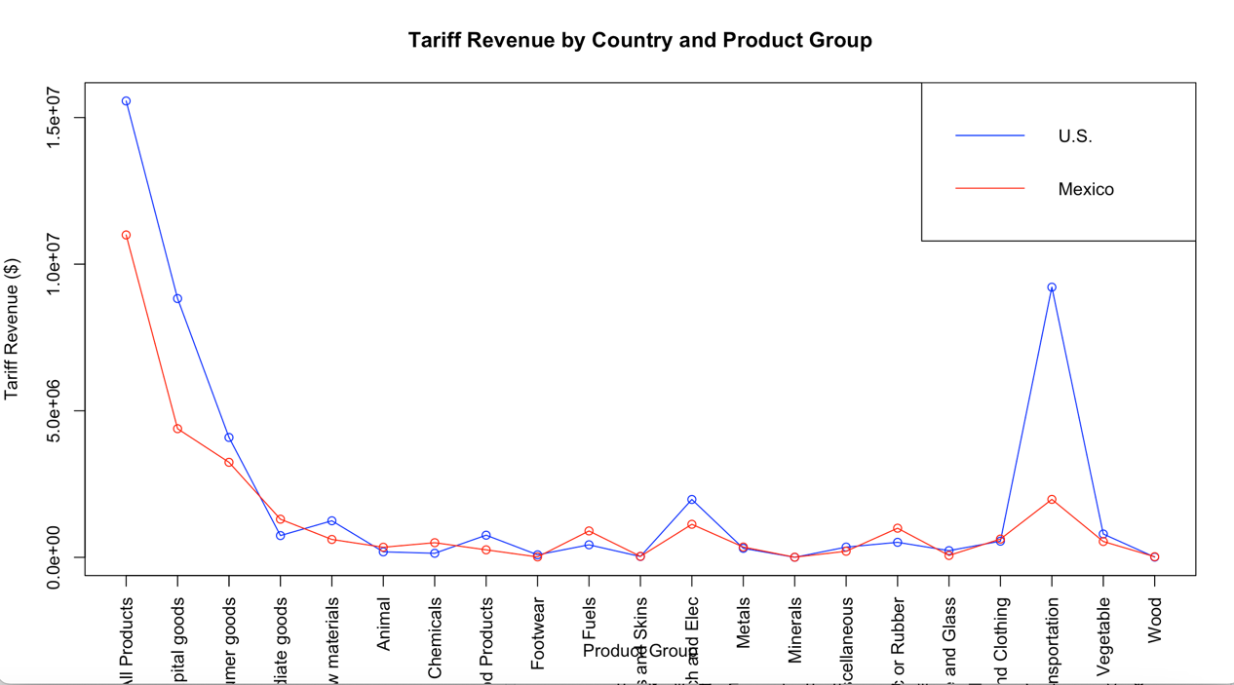
The tariff revenue varies clearly per product type, as this graphic illustrates. Generally speaking, the United States collects more, mostly as a result of bigger import quantities. In one or two areas, Mexico does, however, surpass the United States, indicating a product-specific imbalance.
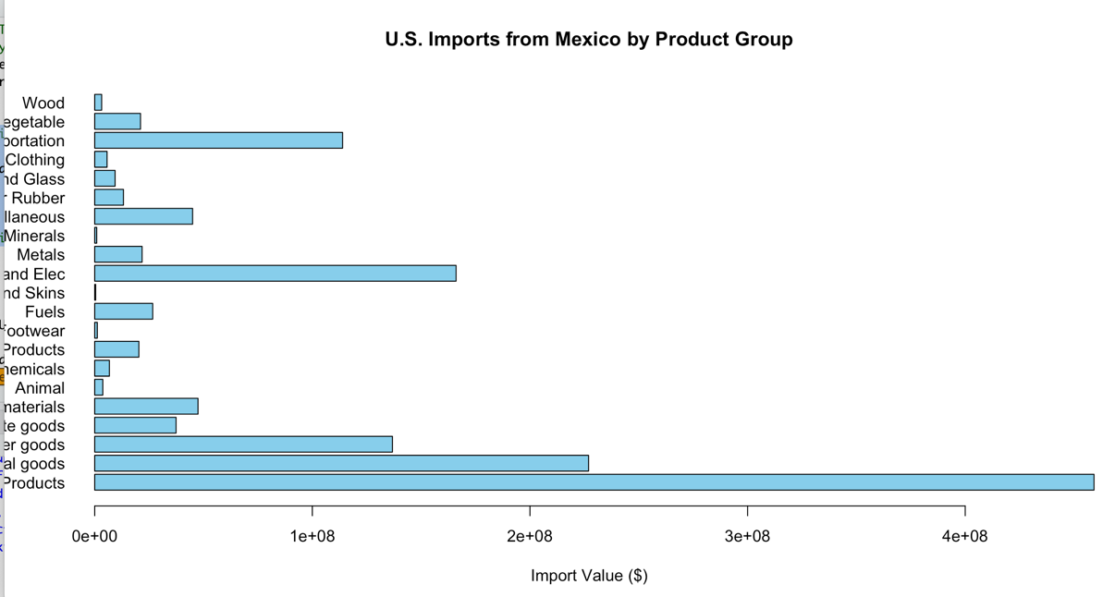

The majority of U.S. imports from Mexico are consumer and capital products. The majority of the imbalance is driven by trade volume rather than tariff rate because these product categories likewise provide the most tariff income.
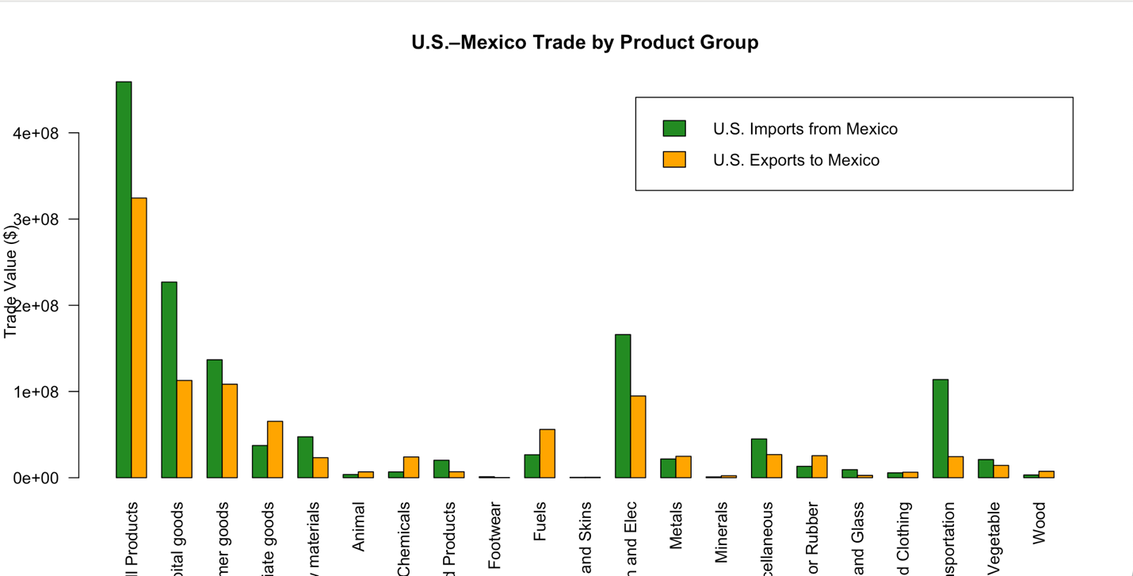

This graph unequivocally demonstrates that the United States imports far more goods than it exports in a number of product categories. The disparity in tariff income collected by each nation is also a result of this trade imbalance.

According to the data, even though both nations implement tariffs, the United States typically receives a larger share of tariff money from Mexican imports than Mexico does from U.S. exports. Higher import quantities in categories like capital goods and consumer goods, rather than noticeably higher tariff rates, are the main cause of this imbalance.
This conclusion was backed by three important visuals: According to a line graph, for the majority of product categories, U.S. tariff income continuously surpasses Mexico's.
The high concentration of U.S. imports in a small number of product categories was demonstrated via a bar chart. Total import and export figures were compared using a grouped bar chart, which showed a glaring trade imbalance favoring Mexico. According to the data, tariff imbalances do occur, but they are mostly caused by variations in trade volume rather than unjust policies. The argument that the United States is generally "tariffed more" than other countries is not well-supported in the context of commerce between the United States and Mexico.

